CO227::Computer Engineering Project – Report

Mic Anywhere

Member’s Name (E/13/043)

Member’s Name (E/13/106) Member’s Name (E/13/319)



**http://www.ce.pdn.ac.lk**

Department of Computer Engineering

Faculty of Engineering

University of Peradeniya

Peradeniya 20200

**Abstract**

In conferences and seminars when the audience is asked to question the presenter or share some ideas distributing the microphone is sometimes a difficult task. In some cases the organizers have to keep 2 or 3 people just to occupy the microphone and distribute as needed.

This mobile application will solve the problem giving the feature to use any mobile phone as a microphone which is connected to wireless network. Anybody who has the application installed can use his phone immediately without waiting for a microphone.

**CONTENTS**

Abstract i

Contents ii

List of figures iii

List of tables iv

**CHAPTER 1** INTRODUCTION  **1**

**CHAPTER 2** RELATED WORK  **2**

**CHAPTER 3** OBJECTIVES AND SCOPE  **4**

**CHAPTER 4** METHODOLOGY **5** 4.1 OVERVIEW 5

4.2ACHIEVEMENTS 6

4.2.1ANOTHER SUB HEADING 6

4.2.2ANOTHER SUB HEADING 6

**CHAPTER 5** CONCLUSION **7**

References  **8**

**LIST OF FIGURES**

Figure 1.1 First figure name 1

Figure 1.2 Second figure name 1

**LIST OF TABLES**

Table 2.1 First table name 2

Table 2.2 Second table name 2

**CHAPTER 1**

**INTRODUCTION**

In conferences and seminars when the audience is asked to question the presenter or share some ideas distributing the microphone is sometimes a difficult task. In some cases the organizers have to keep 2 or 3 people just to occupy the microphone and distribute as needed.

This mobile application and desktop application which are connected to the wi-fi network will solve the above problem.

**CHAPTER 2**

**RELATED WORK**

David Daudelin’s app

David is a technical architect in AT & T’ eeging Markets Group in Piano Texas. He created a new app works over wi-fi or cellular data connection to a laptop computer. The laptop is simply plugged into the speaker system in the conference room. This app transformed mobile phone in to a smart mic.

Crowd Mics

Crowd Mic is an app that turns smartphones and tablets into microphones so the audience can be heard the room’s sound system. The technology work via wifi or Bluetooth receiver. The app also offers a text comment and dial simple polling feature.

While in use the presenter has several options of how he or she allows audience members interact, including selecting a particular participant an “Open Mic ” option and the ability to mute everyone.

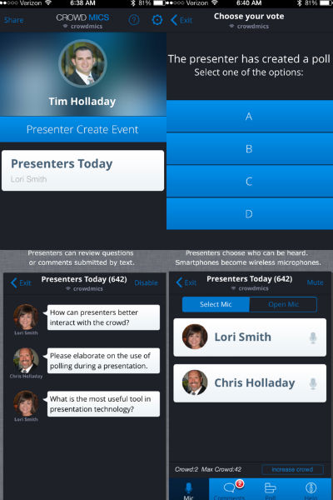

Figure 2.1: Crowd Mics application interface

Von Bruno Microphone and Microphone Pro

Both the Von Bruno Microphone and Microphone Pro are simple apps which turn iPhones into smart mics.

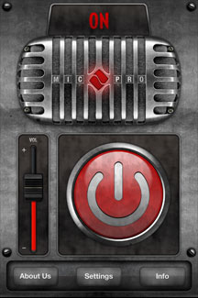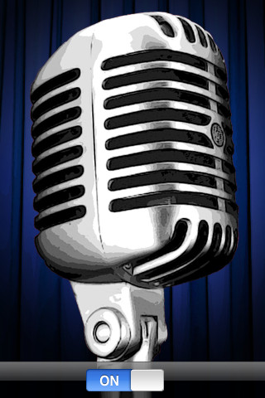

Figure 2.2: Von Bruno Microphone app Figure 2.3:Microphone Pro app

**CHAPTER 3**

**OBJECTIVES AND SCOPE**

<<Modify this document to write your report>>

Video provides a powerful way to help you prove your point. When you click Online Video, you can paste in the embed code for the video you want to add. You can also type a keyword to search online for the video that best fits your document.

To make your document look professionally produced, Word provides header, footer, cover page, and text box designs that complement each other. For example, you can add a matching cover page, header, and sidebar.

Click Insert and then choose the elements you want from the different galleries. Themes and styles also help keep your document coordinated. When you click Design and choose a new Theme, the pictures, charts, and SmartArt graphics change to match your new theme.

When you apply styles, your headings change to match the new theme. Save time in Word with new buttons that show up where you need them. To change the way a picture fits in your document, click it and a button for layout options appears next to it. When you work on a table, click where you want to add a row or a column, and then click the plus sign.

When you work on a table, click where you want to add a row or a column, and then click the plus sign. Reading is easier, too, in the new Reading view. You can collapse parts of the document and focus on the text you want.

If you need to stop reading before you reach the end, Word remembers where you left off - even on another device. Video provides a powerful way to help you prove your point. When you click Online Video, you can paste in the embed code for the video you want to add. You can also type a keyword to search online for the video that best fits your document.

To make your document look professionally produced, Word provides header, footer, cover page, and text box designs that complement each other. For example, you can add a matching cover page, header, and sidebar.

Click Insert and then choose the elements you want from the different galleries. Themes and styles also help keep your document coordinated. When you click Design and choose a new Theme, the pictures, charts, and SmartArt graphics change to match your new theme.

When you apply styles, your headings change to match the new theme. Save time in Word with new buttons that show up where you need them. To change the way a picture fits in your document, click it and a button for layout options appears next to it.

When you work on a table, click where you want to add a row or a column, and then click the plus sign. Reading is easier, too, in the new Reading view. You can collapse parts of the document and focus on the text you want. If you need to stop reading before you reach the end, Word remembers where you left off - even on another device.

**CHAPTER 4**

**METHODOLOGY**

**4.1 OVERVIEW OF METHODOLOGY**

Lorem ipsum dolor sit amet, consectetuer adipiscing elit. Maecenas porttitor congue massa. Fusce posuere, magna sed pulvinar ultricies, purus lectus malesuada libero, sit amet commodo magna eros quis urna. Nunc viverra imperdiet enim. Fusce est.

Vivamus a tellus. Pellentesque habitant morbi tristique senectus et netus et malesuada fames ac turpis egestas. Proin pharetra nonummy pede. Mauris et orci. Aenean nec lorem. In porttitor. Donec laoreet nonummy augue. Suspendisse dui purus, scelerisque at, vulputate vitae, pretium mattis, nunc. Mauris eget neque at sem venenatis eleifend. Ut nonummy.

Fusce aliquet pede non pede. Suspendisse dapibus lorem pellentesque magna. Integer nulla. Donec blandit feugiat ligula. Donec hendrerit, felis et imperdiet euismod, purus ipsum pretium metus, in lacinia nulla nisl eget sapien.

Donec ut est in lectus consequat consequat. Etiam eget dui. Aliquam erat volutpat. Sed at lorem in nunc porta tristique. Proin nec augue. Quisque aliquam tempor magna. Pellentesque habitant morbi tristique senectus et netus et malesuada fames ac turpis egestas.

Nunc ac magna. Maecenas odio dolor, vulputate vel, auctor ac, accumsan id, felis. Pellentesque cursus sagittis felis. Pellentesque porttitor, velit lacinia egestas auctor, diam eros tempus arcu, nec vulputate augue magna vel risus. Cras non magna vel ante adipiscing rhoncus. Vivamus a mi. Morbi neque.

Aliquam erat volutpat. Integer ultrices lobortis eros. Pellentesque habitant morbi tristique senectus et netus et malesuada fames ac turpis egestas. Proin semper, ante vitae sollicitudin posuere, metus quam iaculis nibh, vitae scelerisque nunc massa eget pede. Sed velit urna, interdum vel, ultricies vel, faucibus at, quam.

Donec elit est, consectetuer eget, consequat quis, tempus quis, wisi. In in nunc. Class aptent taciti sociosqu ad litora torquent per conubia nostra, per inceptos hymenaeos. Donec ullamcorper fringilla eros. Fusce in sapien eu purus dapibus commodo. Cum sociis natoque penatibus et magnis dis parturient montes, nascetur ridiculus mus.

Nunc ac magna. Maecenas odio dolor, vulputate vel, auctor ac, accumsan id, felis. Pellentesque cursus sagittis felis. Pellentesque porttitor, velit lacinia egestas auctor, diam eros tempus arcu, nec vulputate augue magna vel risus. Cras non magna vel ante adipiscing rhoncus. Vivamus a mi. Morbi neque.

Aliquam erat volutpat. Integer ultrices lobortis eros. Pellentesque habitant morbi tristique senectus et netus et malesuada fames ac turpis egestas. Proin semper, ante vitae sollicitudin posuere, metus quam iaculis nibh, vitae scelerisque nunc massa eget pede. Sed velit urna, interdum vel, ultricies vel, faucibus at, quam.

**4.2 ACHIEVEMENTS**

**4.2.1 ANOTHER SUB HEADING**

Lorem ipsum dolor sit amet, consectetuer adipiscing elit. Maecenas porttitor congue massa. Fusce posuere, magna sed pulvinar ultricies, purus lectus malesuada libero, sit amet commodo magna eros quis urna. Nunc viverra imperdiet enim.

Fusce est. Vivamus a tellus. Pellentesque habitant morbi tristique senectus et netus et malesuada fames ac turpis egestas. Proin pharetra nonummy pede. Mauris et orci. Aenean nec lorem. In porttitor. Donec laoreet nonummy augue.

Suspendisse dui purus, scelerisque at, vulputate vitae, pretium mattis, nunc. Mauris eget neque at sem venenatis eleifend. Ut nonummy. Fusce aliquet pede non pede. Suspendisse dapibus lorem pellentesque magna. Integer nulla. Donec blandit feugiat ligula. Donec hendrerit, felis et imperdiet euismod, purus ipsum pretium metus, in lacinia nulla nisl eget sapien.

**4.2.2 ANOTHER SUB HEADING**

Lorem ipsum dolor sit amet, consectetuer adipiscing elit. Maecenas porttitor congue massa. Fusce posuere, magna sed pulvinar ultricies, purus lectus malesuada libero, sit amet commodo magna eros quis urna. Nunc viverra imperdiet enim.

Fusce est. Vivamus a tellus. Pellentesque habitant morbi tristique senectus et netus et malesuada fames ac turpis egestas. Proin pharetra nonummy pede. Mauris et orci. Aenean nec lorem. In porttitor. Donec laoreet nonummy augue.

Suspendisse dui purus, scelerisque at, vulputate vitae, pretium mattis, nunc. Mauris eget neque at sem venenatis eleifend. Ut nonummy. Fusce aliquet pede non pede. Suspendisse dapibus lorem pellentesque magna. Integer nulla. Donec blandit feugiat ligula. Donec hendrerit, felis et imperdiet euismod, purus ipsum pretium metus, in lacinia nulla nisl eget sapien.

**CHAPTER 5**

**CONCLUSION**

In conferences, seminars when the audience is asked to question the presenter or share some ideas, distributing the microphone is sometimes a difficult task.

This mobile application will solve the problem giving the feature to use mobile phone as a microphone which is connected to wireless network.

**REFERENCES**

[1]J. Jones. (1991, May 10). Networks (2nd ed.) [Online]. Available: http://www.atm.com

[2] N. Kawasaki, “Parametric study of thermal and chemical nonequilibrium nozzle flow,” M.S. thesis, Dept. Electron. Eng., Osaka Univ., Osaka, Japan, 1993.

[3] W. Rafferty, “Ground antennas in NASA’s deep space telecommunications,” Proc. IEEE vol. 82, pp. 636-640, May 1994.

[4] R. L. Myer, “Parametric oscillators and nonlinear materials,” in Nonlinear Optics, vol. 4, P. G. Harper and B. S. Wherret, Eds. San Francisco, CA: Academic, 1977, pp. 47-160.

[1] <http://aztechbeat.com/2014/03/startup-crowd-mics-phone-wireless-mic/>

[2] <http://www.njit.edu/features/alumni/smart-mic.php>

[3] <http://ccnmtl.columbia.edu/enhanced/solutions/iphone_into_simple_pa_system.html>